- To access this training, please go to the following URL: https://www.hrclassroom.com/Trainings/Login.aspx?GID=A1724F7R0

- When you click the link, you will be taken to the HR Classroom training website and asked for your email address.
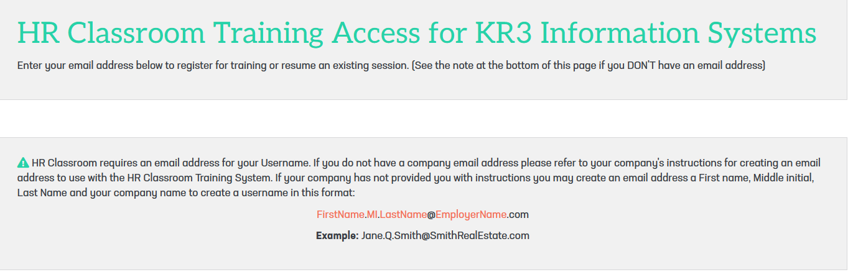

- HR Classroom will look to see if you’ve taken a training previously. If not, it will ask you to create a personal account.

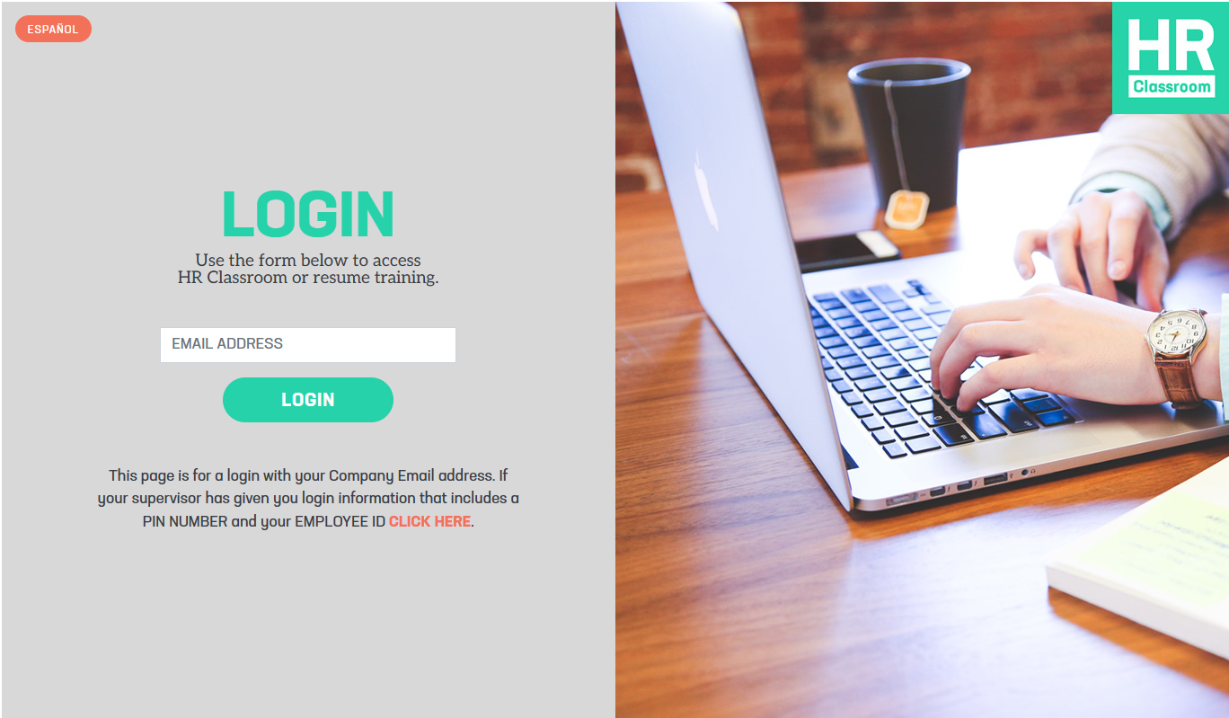
4. You will need to enter:
- First Name
- Last Name
- Email Address

You will also be asked to create a password and then confirm it. You must type the password EXACTLY the same each time (using the same letters, uppercase or lowercase, etc.).

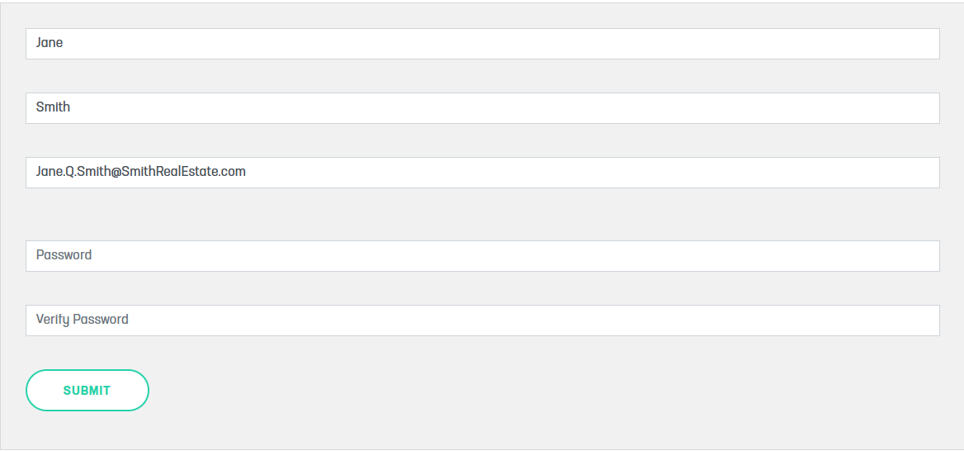
- Once you’ve created your account, click the training title and take the training.

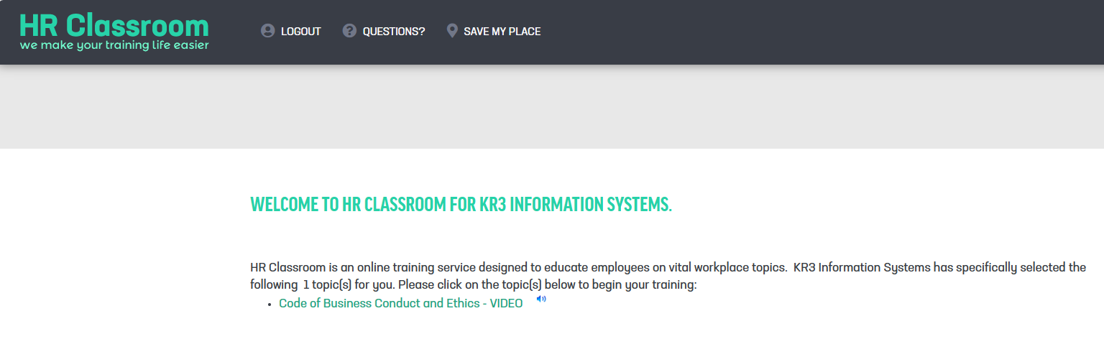
Note: If you are interrupted, you can always pick up where you leave off by clicking the link above, then entering your email and password again.

Use the ‘Previous’ and ‘Next’ buttons to navigate through each training.

Do NOT use your browser’s back button!

